
Welcome, Sumit!
Welcome to Linkific! We’re excited to have you on board and look forward to working with you throughout your internship. This document will guide you on how things work, what to expect, and whom to reach out to if you need any help.
___________________________________________________________________

INTERNSHIP OVERVIEW
Working Days: Monday to Saturday
Internship Duration: 4 months
___________________________________________________________________
COMMUNICATION CHANNELS
- You will be added to the following WhatsApp groups:
- Linkific Interns – General updates and announcements
- Linkific Tech Team (Interns) – Tasks, updates, and team coordination
- You’ll also receive login credentials for the Linkific dashboard, which you will use to view and submit tasks, apply for leave, and access internship-related information. (Daily dashboard log in at 9
Important:
Please remain active in these channels, as all key communication will take place here.
___________________________________________________________________
INTERNSHIP FLOW

Onboarding Day
- Attend the scheduled onboarding meeting
- Be added to relevant WhatsApp groups and log in to the Linkific dashboard using the credentials provided
- Join the Tech Meet at 8:00 PM and be introduced to the team
- Tasks will begin from the following working day

Month 1: Training Phase
- You will undergo a structured training period before being assigned to a project.
- Tasks will be assigned either the night before or the morning of via the Linkific dashboard.
- You will be required to join the Daily Tech Meet and present your task
- You must maintain a Google Sheet, Google Doc, and Github Repository to track your progress.

Daily Tech Meet
🕗 8:00 PM, Monday to Saturday
🔗 https://meet.google.com/tok-ceob-icj
(Also available in the Tech Team WhatsApp group description)

During the session:
- Present your work by sharing your screen and reporting the deliverables of your task
- Keep updates concise — maximum 4 minutes per person
- Use the session to clarify any doubts
- Note: If you are late to join, a reminder may be sent in the group as part of the regular process.

Format to follow for daily update:
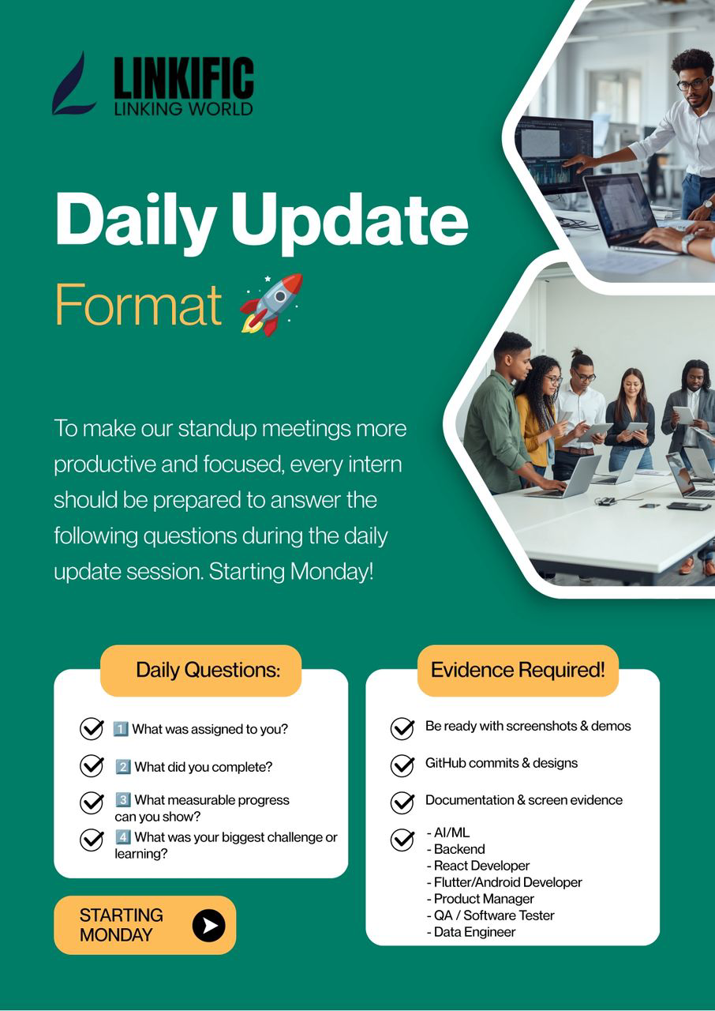

Google Sheet Tracker
- Maintain a Google Sheet to track your daily tasks and Tech Meet participation.
- Required Columns: Date, Day, Task, Description, Tools & Tech Used, Status, Output, Meeting Conducted By, Meeting Time, Participants
- Share editorial access with both emails below:
hr.linkific@gmail.com

Google Doc
- Maintain a single Google Doc throughout the training period
- Create a separate tab for each training day to document your tasks
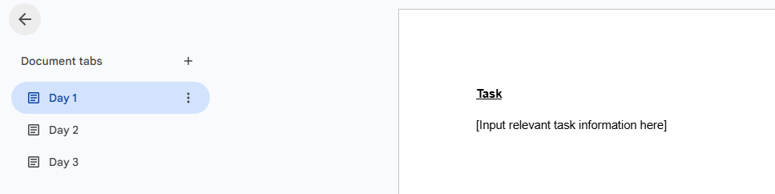

Github Repository
- Create a repository named "Linkific Tasks"
- Create a separate folder for each training day (e.g., Day 1, Day 2, Day 3)

Months 2–4: Project Phase
- You will be assigned to a live project
- Apply your training to real-world tasks
- Meeting structures may vary depending on project requirements
___________________________________________________________________
LEAVE POLICY
- A minimum of 80% attendance is required to receive your Certificate of Completion.
- You are entitled to 12 days of leave during the internship period.
- Reminder: Exceeding your allotted leave may cause your attendance to fall below the 80% requirement, which may affect your Certificate of Completion

How to Request Leave
- Submit a leave request on the Linkific Dashboard (1–2 days in advance)
- Send an email to HR at hr.linkific@gmail.com
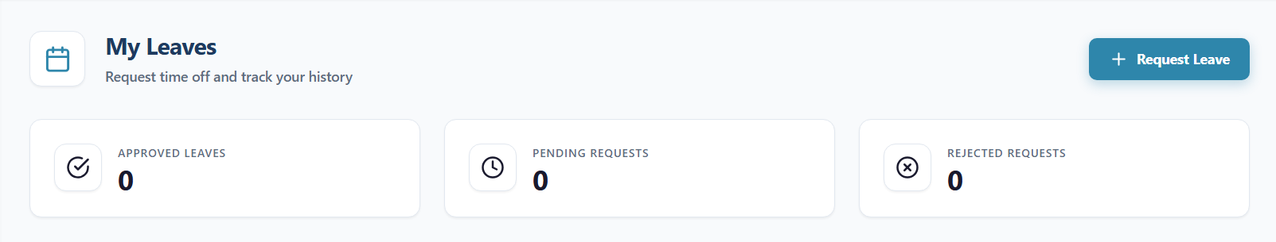

Leave Guidelines (Additional Cases):
- Emergency Leave: May be requested on the same day with a valid reason, subject to approval.
- Exam Leave: Please submit your leave request on the dashboard and email HR with your exam timetable attached for reference. Leave will be reviewed with consideration for academic commitments.
___________________________________________________________________
CONTACT
For any questions or concerns regarding your internship, please reach out to:
Email: hr.linkific@gmail.com

Ms. Divya Sawarkar  COO  +91 76207 94821 | Mr. Aditya Bondre  CTO  +91 95459 85732

Garima Pandey  HR Team  91 92502 81525 | Namah Sharma  HR Team  +91 9682666981 | Chanda Pandey  HR Team  +91 70097 65266

Note: If you have any concerns or grievances, please feel free to reach out to HR. All matters will be treated with strict confidentiality.
___________________________________________________________________

FINAL NOTE
We encourage you to:
- Ask questions
- Stay proactive
- Make the most of your experience
We’re excited to have you with us and wish you a rewarding internship experience at Linkific!

